MYSQL QUERY

FOR FINANCIAL ANALYSIS

**Financial overview & performance**

**1**  ***over the year did the company spend more or less than planned***

-- Total Actual Expenses

SELECT SUM(AMOUNT) AS TotalActualExpenses

FROM transaction

WHERE `REVENUE/EXPENSES` = 'Expenses';



-- . Total Budgeted Expenses

SELECT SUM(BUDGET) AS TotalBudgetedExpenses

FROM budget

WHERE `REVENUE/EXPENSES` = 'Expenses';



-- Compare Actual vs Budgeted Spending

SELECT

TotalActualExpenses,

TotalBudgetedExpenses,

CASE

WHEN TotalActualExpenses > TotalBudgetedExpenses THEN 'More'

WHEN TotalActualExpenses < TotalBudgetedExpenses THEN 'Less'

ELSE 'Equal'

END AS SpendingComparison

FROM (

SELECT

(SELECT SUM(AMOUNT) FROM transaction WHERE `REVENUE/EXPENSES` = 'Expenses') AS TotalActualExpenses,

(SELECT SUM(BUDGET) FROM budget WHERE `REVENUE/EXPENSES` = 'Expenses') AS TotalBudgetedExpenses

) AS Comparison;



**2 Was the company profitable each month, or did expenses exceed income at any point?**

SELECT

DATE_FORMAT(DATE, '%Y-%m') AS month,

SUM(CASE WHEN `REVENUE/EXPENSES` = 'Revenue' THEN AMOUNT ELSE 0 END) AS total_revenue,

SUM(CASE WHEN `REVENUE/EXPENSES` = 'Expenses' THEN AMOUNT ELSE 0 END) AS total_expenses,

SUM(CASE WHEN `REVENUE/EXPENSES` = 'Revenue' THEN AMOUNT ELSE 0 END)

- SUM(CASE WHEN `REVENUE/EXPENSES` = 'Expenses' THEN AMOUNT ELSE 0 END) AS net_profit

FROM transaction

GROUP BY month

ORDER BY month;

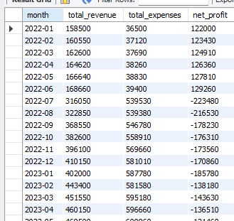

**3** **Which categories or accounts show the largest difference between budget and actual figures?**

SELECT

t.COD_ACCOUNT,

t.ACCOUNT,

t.CLASS,

SUM(t.AMOUNT) AS actual_amount,

SUM(b.BUDGET) AS budget_amount,

SUM(t.AMOUNT) - SUM(b.BUDGET) AS difference

FROM transaction t

JOIN budget b

ON t.COD_ACCOUNT = b.COD_ACCOUNT

GROUP BY t.COD_ACCOUNT, t.ACCOUNT, t.CLASS

ORDER BY ABS(difference) DESC

LIMIT 10;

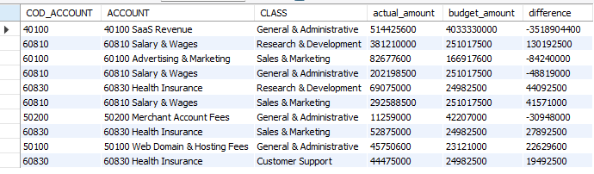

**REVENUE INSIGHTS**

**1 What are the main revenue sources, and which one generates the most income?**

SELECT `MEMO/DESCRIPTION`, NAME, `REVENUE/EXPENSES`, SUM(AMOUNT) AS TotalRevenue

FROM transaction

WHERE `REVENUE/EXPENSES` = 'Revenue'

GROUP BY `MEMO/DESCRIPTION`, NAME, `REVENUE/EXPENSES`

ORDER BY TotalRevenue DESC

LIMIT 10;

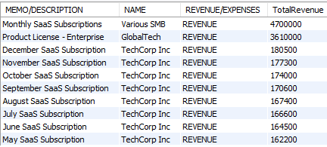

**2 Which revenue sources have shown the most growth or decline over time**

SELECT

DATE_FORMAT(DATE, '%Y-%m') AS month,

ACCOUNT,

SUM(AMOUNT) AS total_revenue,

LAG(SUM(AMOUNT)) OVER (PARTITION BY ACCOUNT ORDER BY DATE_FORMAT(DATE, '%Y-%m')) AS previous_month_revenue,

(SUM(AMOUNT) - LAG(SUM(AMOUNT)) OVER (PARTITION BY ACCOUNT ORDER BY DATE_FORMAT(DATE, '%Y-%m'))) AS revenue_change,

ROUND(((SUM(AMOUNT) - LAG(SUM(AMOUNT)) OVER (PARTITION BY ACCOUNT ORDER BY DATE_FORMAT(DATE, '%Y-%m'))) / LAG(SUM(AMOUNT)) OVER (PARTITION BY ACCOUNT ORDER BY DATE_FORMAT(DATE, '%Y-%m'))) * 100, 2) AS percentage_change

FROM transaction

WHERE `REVENUE/EXPENSES` = 'Revenue'

GROUP BY month**,** ACCOUNT

ORDER BY month, percentage_change DESC;

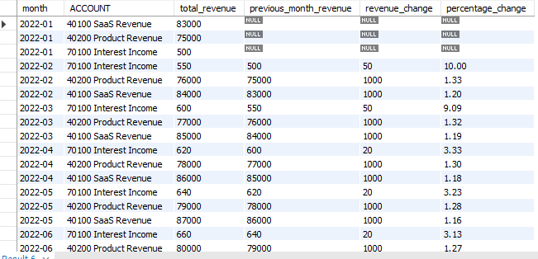

**3 Which clients or deals brought in the highest individual payments?**

select name,`REVENUE/EXPENSES`, sum(AMOUNT) as TotalRevenue

from transaction

where `REVENUE/EXPENSES` = 'Revenue'

group by name,`REVENUE/EXPENSES`

order by TotalRevenue desc

limit 5;

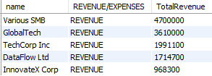

**4 where there specific months when revenue was noticeably lower than planned**

SELECT

DATE_FORMAT(t.DATE, '%Y-%m') AS month,

SUM(t.AMOUNT) AS actual_revenue,

SUM(b.BUDGET) AS budgeted_revenue,

SUM(t.AMOUNT) - SUM(b.BUDGET) AS revenue_difference,

CASE

WHEN SUM(t.AMOUNT) < SUM(b.BUDGET) THEN 'Below Budget'

ELSE 'On Target or Above'

END AS revenue_status

FROM transaction t

JOIN budget b ON t.COD_ACCOUNT = b.COD_ACCOUNT

WHERE t.`REVENUE/EXPENSES` = 'Revenue'

GROUP BY month

ORDER BY revenue_difference ASC;

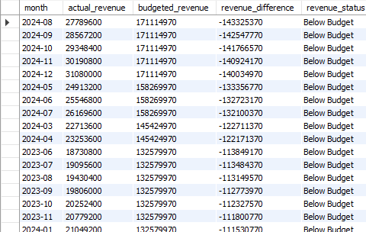

**Expense insigts**

**1 Top 5 Spending Categories by Total Amount**

SELECT CLASS, SUM(AMOUNT) AS total_spent

FROM transaction

WHERE `REVENUE/EXPENSES` = 'Expenses'

GROUP BY CLASS

ORDER BY total_spent DESC

LIMIT 5;

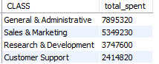

**2 vendor that received the most money overall**

SELECT NAME, SUM(AMOUNT) AS total_paid

FROM transaction

WHERE `REVENUE/EXPENSES` = 'Expenses'

GROUP BY NAME

ORDER BY total_paid DESC

LIMIT 5;

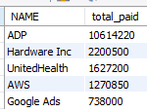

**3. Expense Categories Regularly Exceeding Their Budget**

SELECT b.CLASS,

SUM(t.AMOUNT) AS actual_spending,

SUM(b.BUDGET) AS budgeted_spending,

SUM(t.AMOUNT) - SUM(b.BUDGET) AS difference,

CASE

WHEN SUM(t.AMOUNT) > SUM(b.BUDGET) THEN 'Over Budget'

ELSE 'Within Budget'

END AS budget_status

FROM transaction t

JOIN budget b ON t.CLASS = b.CLASS

WHERE t.`REVENUE/EXPENSES` = 'Expenses'

GROUP BY b.CLASS

ORDER BY difference DESC;

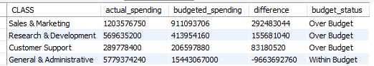

**4 Months with Sharp Spending Increases & Causes**

SELECT

monthS,

TotalExpenses,

TotalRevenues,

CASE

WHEN TotalExpenses > TotalRevenues THEN 'over spending'

WHEN TotalRevenues > TotalExpenses THEN 'profite'

ELSE 'Equal'

END AS SpendingComparison

FROM (

SELECT

DATE_FORMAT(DATE, '%Y-%m') AS monthS,

SUM(CASE WHEN `REVENUE/EXPENSES` = 'Expenses' THEN AMOUNT ELSE 0 END) AS TotalExpenses,

SUM(CASE WHEN `REVENUE/EXPENSES` = 'Revenue' THEN AMOUNT ELSE 0 END) AS TotalRevenues

FROM transaction

GROUP BY monthS

) AS monthly_summary

ORDER BY monthS;

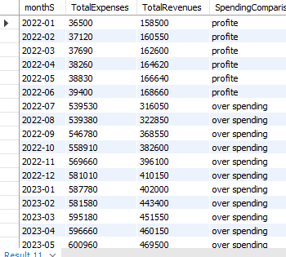

Trends & pattern

1 Which months shows the best alignment between budgeted and actual figures

SELECT

DATE_FORMAT(t.DATE, '%Y-%m') AS months,

SUM(t.AMOUNT) AS actual_revenue,

SUM(b.BUDGET) AS budgeted_revenue,

SUM(t.AMOUNT) - SUM(b.BUDGET) AS revenue_difference,

CASE

WHEN SUM(t.AMOUNT) > SUM(b.BUDGET) THEN 'Above Budget'

ELSE 'aligned budget'

END AS revenue_status

FROM transaction t

JOIN budget b ON t.COD_ACCOUNT = b.COD_ACCOUNT

WHERE t.`REVENUE/EXPENSES` = 'REVENUE'

group by months

ORDER BY revenue_difference ASC;

